Date: February 14, 2024

SMART INTERNZ - APSCHE

AI / ML Training

Assessment

l. Write a Python programto calculate the area of a rectangle given its length and width.

2. Write a program to convert miles to kilometers

3 Write a function to check if a glven string ls a palindrome.

1. Write a Python programto find the second largestelement in a list.
2. Explain what indentation means in Python.
3. Write a program to perform set difference operation.
4. Write a Python program to print numbersfrom l to 10 using a while loop.
5. Write a program to calculate the factorial of a number using a while loop.
6. Write a Python program to check if a numbflf lS OSltive, negative, or zero using lf-elif-else

statements.

1. Write a program to determine the largest among three numbers using conditlonal

statements.

l l. Write a Python program to create a numpy array filled with ones of given shape.

1. Write a program to create a 2D numpy array initialized with random integers
2. Write a Python program to generate an array of evenly spaced numbers over a specified

range using llnspace.

1. Write a program to generate an array of 10 equally spaced values between 1 and 100 using

llnspace.

1. Write a Python program to create an array contalning even numbers from 2 to 20 using

arange.

1. Write a program to create an array containing numbers from l to 10 with a step size of 0.5

using arange.

1.

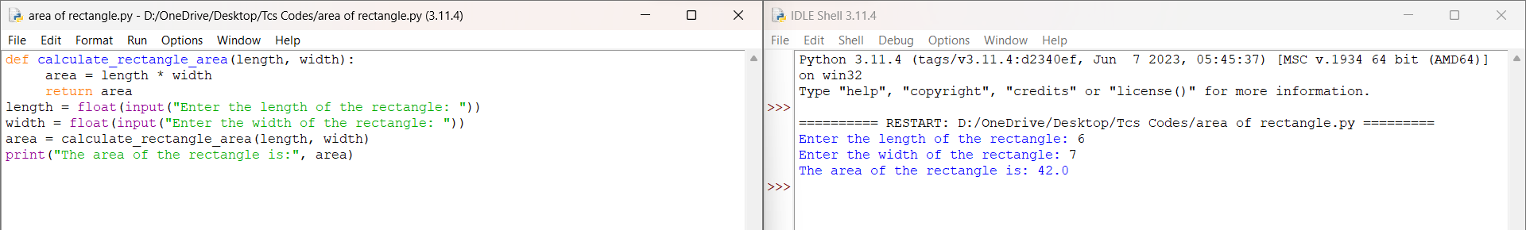

2.

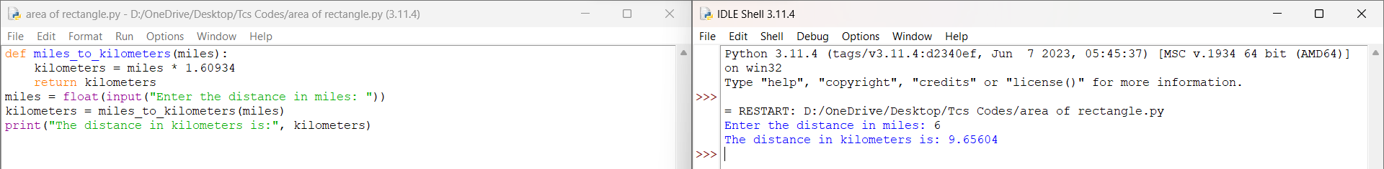

3.

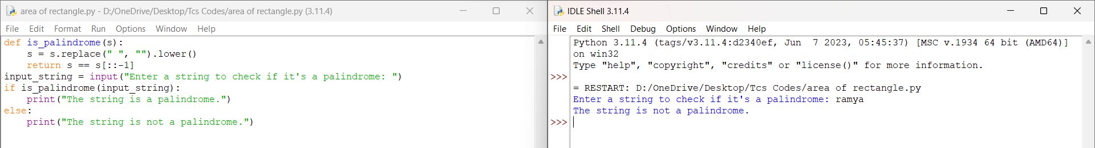

4.

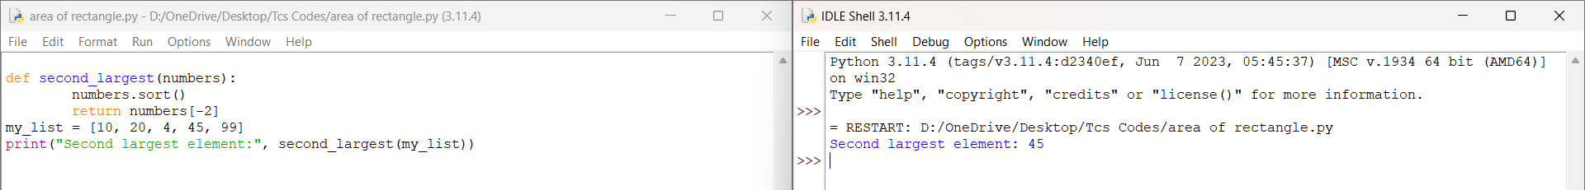

5.

Indentation in Python is used to define blocks of code. It is crucial for the structure and readability of Python code because Python uses indentation to indicate blocks of code, such as those within loops, conditionals, functions, and classes. Unlike many other programming languages that use braces {} or keywords like begin and end to define blocks, Python uses indentation consistently to denote the beginning and end of blocks.

6.

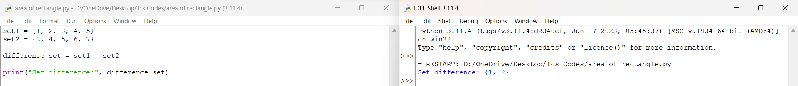

7.

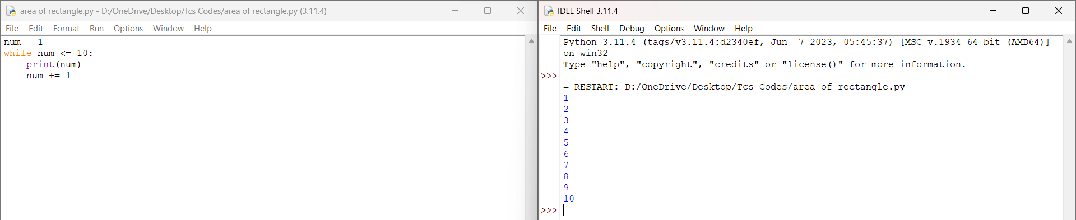

8.

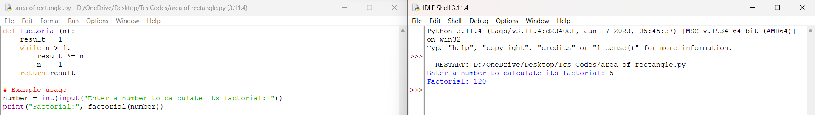

9.

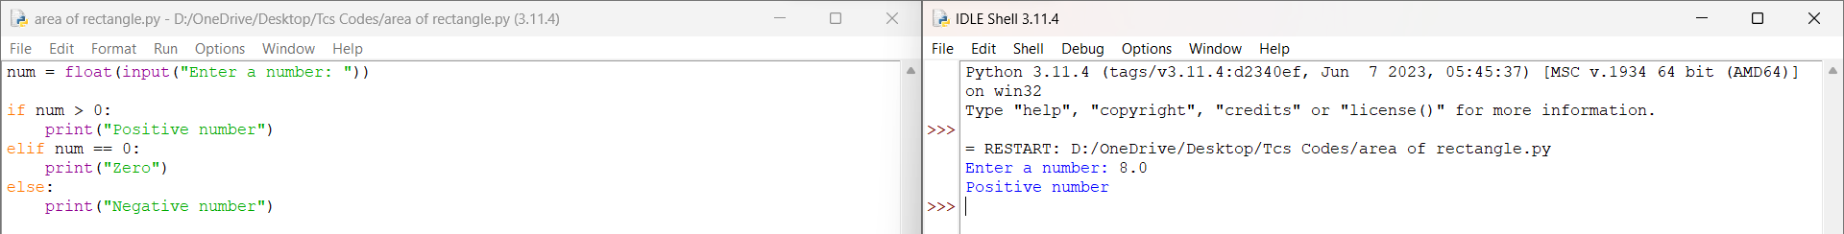

10.

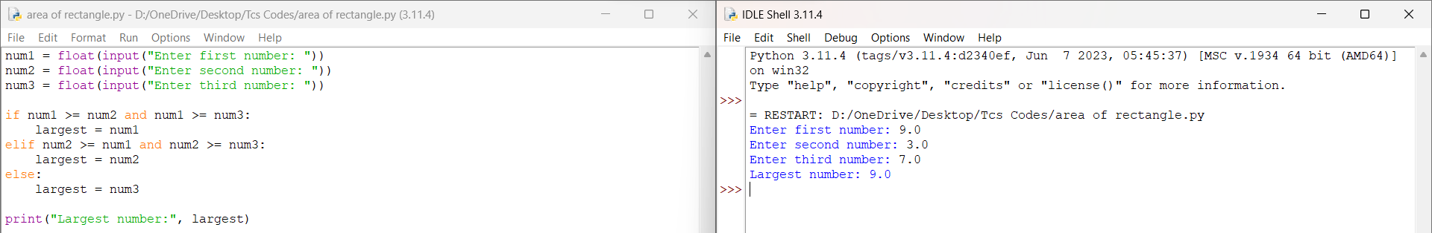

11.

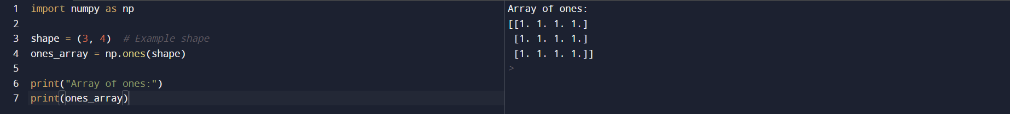

12.

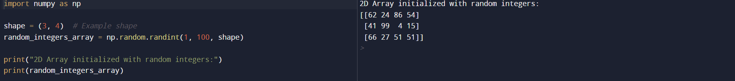

13.

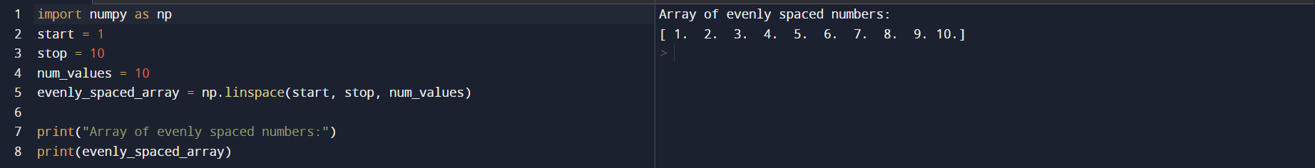

14.



15.



16.



Scanned with CamScanner